**Ex-1 Difference of Prompt and Alert**

1. Create a variable and print "Hello JavaScript" in alert box.

2. Get an input from prompt box and display it in the alert box.

**Ex-1.1 Prompt box**

Get an input from user using prompt box and validate using switch case

**Ex-2 Input value display in alert box**

Get an input from the user and display it in pop-up when the user hit the display button.

**Ex-3 Comparison of two inputs**

Get two inputs from the user and compare whether it is equal or not. If it is equal then it should pop-up "Data's are equal" message.

**Ex-4 Form validation**

Get two inputs from the user and validate it using a button whether any one of the input contains any null value or not. If it contains null then pop-up a message stating that "One of your data is empty, kindly fill it and try again:)"

**Ex-5 Arithmetic operation and display the output using Inner HTML**

Get two inputs from the user and perform all Arithmetic operation. Display each one of the ouput using Inner HTML.

**Ex-6 Listing data using iteration - 1**

Get input from the user where it should accept only the integer. Display all the values in a select box using mouse event.

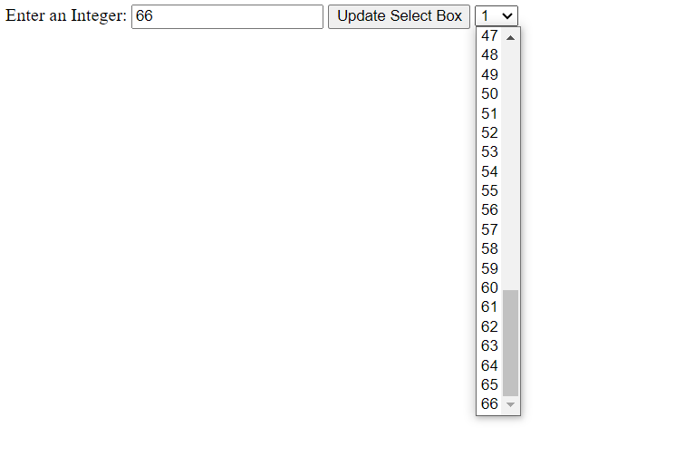

**Ex-7 Listing data using iteration - 2**

Get input from the user where it should accept only the integer. Display the values in a select box using keyboard event.

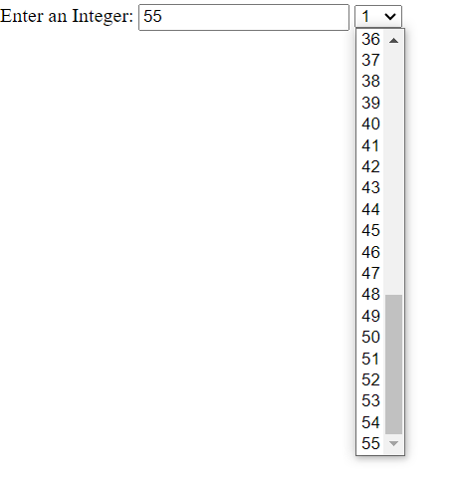

**Ex-8 Listing data using iteration – 3**

Get an input from the user, display the values in a drop-down. Select a specific value where it should list-down all the previous values using Inner HTML.

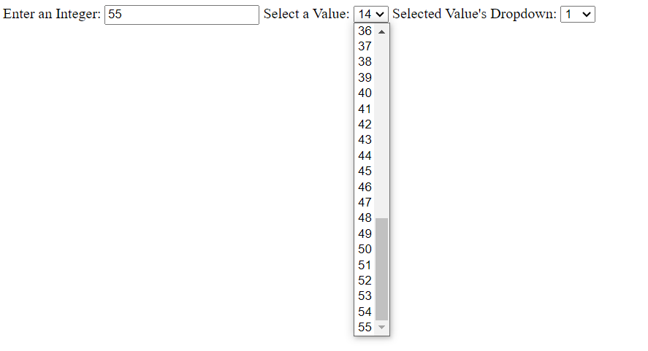

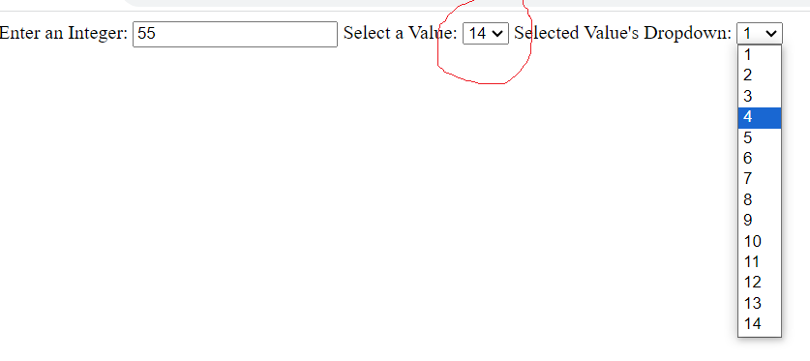

**Ex-9 Listing data using iteration –**

Get an input from the user, display the values in a drop-down. Select a specific value and the equvalent form should be created along with two values "Username" and "Password" with empty values where user will fill out the data.

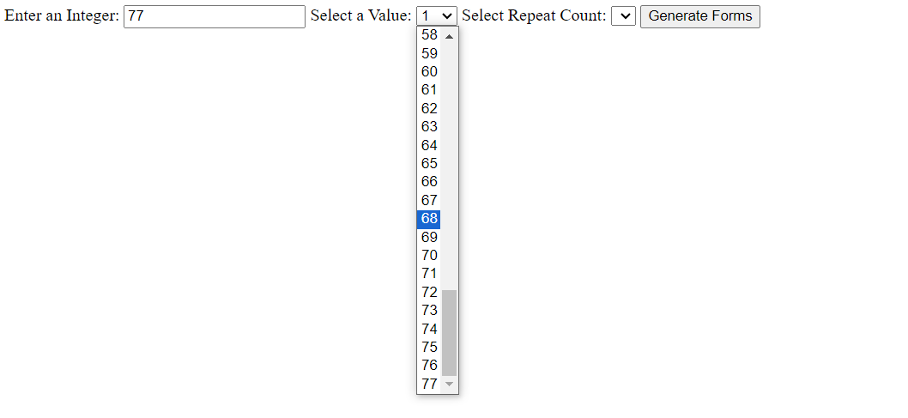

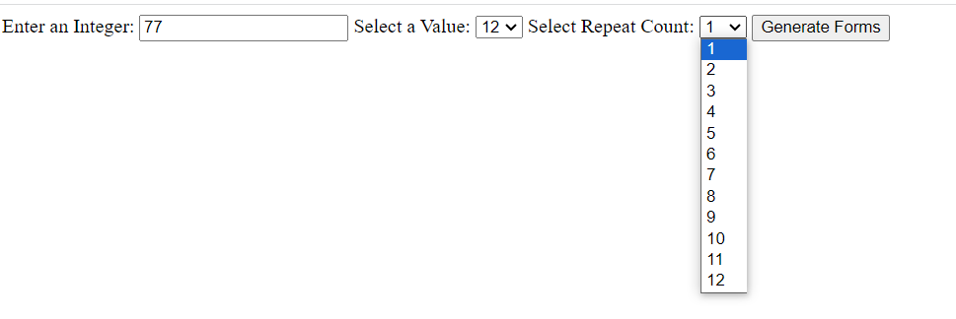

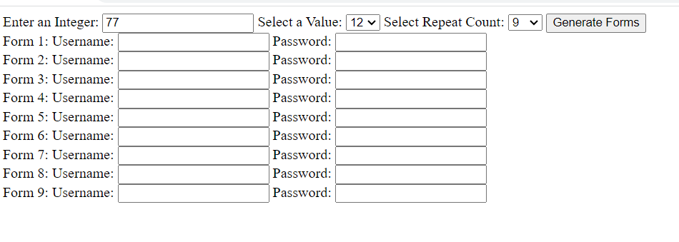

**Ex-10 Password creation**

Get name, dob from user. Take the first four letter from the name and concat the birth date then it should be act as an input to the password field.

**Ex-11 Date function**

create to javascript function to get date from user and used to display date with +5 days and -5days from the getting date and display either in input box